Nepal College of Information Technology
Assessment
Spring 2011
Program : BE ELX Time : 3 hrs
Semester : Spring (IV) FM : 100
Subject : Numerical Methods PM : 45

- Candidates are requested to give their answer as far as practicable in their own words.
- The figure in the margin indicates the full marks
- Attempt ALL question

1. a) Solve
X⁵-3x²-100=0 correct to three decimal place by secant method. 7
b) Solve 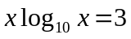 by N-R method correct to four decimal places. 8

2. a) Given the data

X | 1.2 | 1.3 | 1.4 | 1.5
f(x) | 1.063 | 1.091 | 1.119 | 1.145
i) Calculate f(1.35) using Newton’s interpolating polynomial of degree 1 through 3. Choose base points to attain good accuracy.
ii) Comment on the accuracy of results on the order of polynomial. 8
b) Fit a power function model 7
y = ax^{b}
to the following data

X | 2 | 4 | 6 | 8
Y | 1.4 | 2.0 | 2.4 | 2.6

3. a) Evaluate
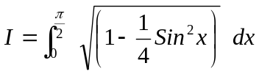
By using Gaussian two and three point formula. 7
b) Evaluate 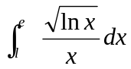 by using
i) Trapezoid rule
ii) Simpson’s and Rule. 8
4. a) Solve
2x -7y -10z = -17
5x +y + 3z = 14
x +10y+ 9z =7
By Gauss-seidal method 8
b) Find the largest eigen value and corresponding Eigen vector of the matrix
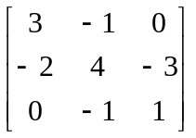 7

5. a) Solve 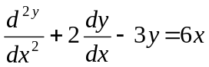
Y(0) = 0, y’(0) = 1 for y(0.2) by Huen’s method taking h = 0.2. 7
b) Solve = y + Sinx
y(0) = 2 for y(2.2)
by RK-4th order taking h = 0.1 8

6. a) Torsion on a rectangular subject to twisting is governed by
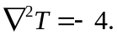
Given the condition T = 0 on the boundary, find T over a cross section of a bar of Size 9cm x 9cm using a grid Size of 3cm x 3cm. 10
b) Find square root of 17 by fixed point iteration method. 5

7. Write short notes on (Any two) 2*5
a) Error in numerical computing
b) Ill condition system
c) Cubic spline interpolating polynomial.

